Software Testing Mini Campaign
[15 Points (equivalence class) + 15 points (boundary value), Week 9] Work out an equivalence class
partitioning and boundary value analysis for blackbox testing of your program. Explain all the equivalence
classes, examples of boundary/middle values in each equivalence class and the rationale behind your choices.

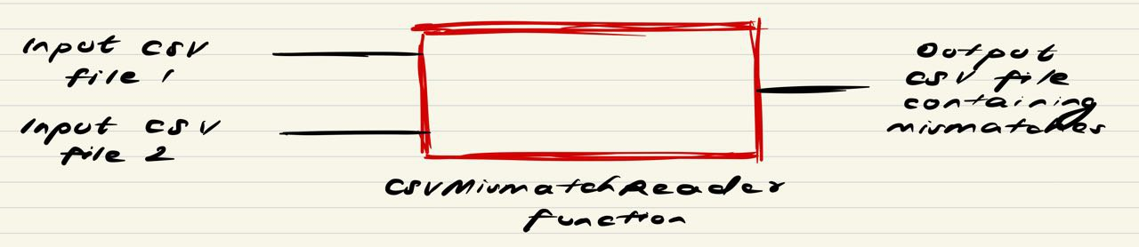

We know that in equivalence partitioning, equivalence classes are evaluated for given input conditions. From our use case diagram from part 2, we know that the input requirement in this case would be the necessity to enter only valid path names. Therefore, we can essentially divide our case into two equivalence classes that represents valid and invalid states.
- Equivalence class 1: Valid path names given as inputs for the CSV files in scanner class
In the function CSVMismatchReader, valid input path names are given to scanner objects csv1 and csv2 resulting in the generation of output.csv that contains a list of all the exceptions based on comparing the records stored in these CSV files row by row against a unique combination.
For example, valid path names for csv1 and csv2 include:
- ./csv_files/sample_file_1.csv
- ./csv_files/sample_file_3.csv
Boundary Value Analysis:
- Middle value: ./csv_files/sample_file_1.csv
- Boundary value: C:\Users\annma\OneDrive\Documents\Ann SUTD Files\Term 5\ESC\ESC-Mini Campaign\ESC-Mini-Campaign\csv_files\sample_file_1.csv
The middle value is the shortened path of csv file which is truncated and starts with ./ to allow the file to be read. The boundary value is the maximum length of the path of the csv file and the actual full path of the csv file.
- Equivalence class 2: Invalid path names given as inputs for the CSV files in scanner class
In the function CSVMismatchReader, invalid input path names are given to scanner objects csv1 and csv2 resulting in the generation of output.csv that is empty and contains no records.
For example, invalid path names for csv1 and csv2 include:
- sample_file_1.csv
- sample_file_3.csv
(file path name is incomplete and doesn’t specify the name of the directory or subdirectory in which it is contained)

- ./.vscode/sample_file_1.csv
- ./.vscode/sample_file_3.csv
(csv files not stored under .vscode directory)
Boundary Value Analysis:
- Middle value: ./.vscode/sample_file_1.csv
- Boundary value: sample_file_1.csv
The middle value contains the wrong path with the wrong directory ‘.vscode’ but still in the format of the path: ./.vscode/sample_file_1.csv. The boundary value is which is the name of csv file sample_file_1.csv which is not even in the format of the path and the scanner class cannot accept the name of csv file

